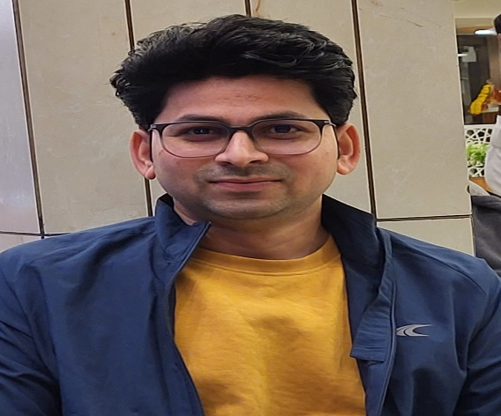

CHIRAG SHARMA
MA, B.Ed., PhD (Pursuing)

Assistant Professor of English (GES Class II, Gazetted) with a fine academic grounding in literature and film studies, presently serving at Government Arts and Commerce College, Kathlal, from June 2025 onwards. His academic trajectory includes a B.A. and B.Ed. with distinction in English, an M.A. in English (Literature), and a PhD in progress in Film Semiotics, reflecting a focused engagement with the interface of literature, cinema and critical theory. Having qualified for the GPSC Assistant Professor, as well as the NET-JRF (Twice), NET, and GSET, he brings to the classroom a rigorous command of his discipline and contemporary research methodologies. His experience ranges from teaching at the school level to the tertiary sector, which has enabled him to develop a nuanced understanding of learner needs, curriculum implementation and language proficiency development. Alongside teaching, he actively participates in faculty development programmes, workshops and conferences on literature, films, media and research methodology, underscoring his commitment to continuous professional growth and to nurturing an academically vibrant environment for his students.

